**Institute of Technology Tralee**

**Ord/Hons BSc. in Computing with Specialism (Groups B and C) - Year 1**

**Continuous Assessment #3**

**Date: 26/4/13**

**Time: 9 a.m. – 11.30 a.m.**

**Object Oriented Programming 1**

**Instructions:** Attempt the following question. You should use the JCreator IDE. When you are finished coding, print out your code in **landscape** format.

**________________________________________________________**

**Q1.**

Write a Java program that contains a JFrame window. This window should contain 2 labels and a 2 buttons. It should have dimensions of 300 x 150 pixels. It should use a flow-layout style and the application should terminate when the close button is hit on its title bar. The window should be placed at location (300,300) on the screen when the application launches.

The buttons should have the text “red” and “green” written on them respectively. If the user clicks on the “red” button then the window should turn red in colour. Should the user click on the “green” button then the window should turn green. The buttons themselves will remain in their default greyish colour throughout. Note that in order to change the window’s colour, a reference to the window’s “content pane” must first of all be obtained using the method **getContentPane**(). The labels should display counts of the total number of times each button has been clicked (zero to begin with).

You should make use of the **appendix** of method definitions from the X: drive when answering this question.

For full marks your program should, along with a logically correct solution for the problem above, include comments and meaningful variable names.

Some sample runs of the program are as illustrated below.

**Sample Screenshots**

**When the application first launches:**

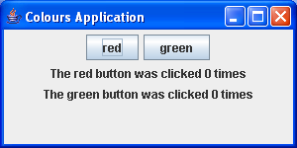

**Pressing the “red” button for the first time:**

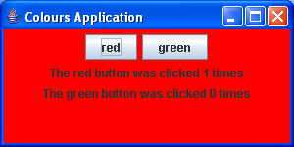

**Pressing the “green” button for the first time:**

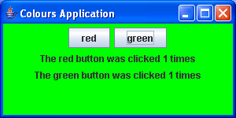

**….. many clicks later**

